BILLING SYSTEM FOR GROCERY STORE

1. Introduction
Efficient management of billing operations is essential in any grocery store. Traditional manual billing methods often lead to errors, longer waiting times, and poor inventory tracking.
The Billing System for Grocery Store automates the billing process by generating accurate bills, calculating taxes, and managing product and customer information in a secure and efficient manner.
This project provides a simple and user-friendly interface for store employees to handle customer purchases and print receipts instantly.

2. Project Description
The project is developed using Java (executed in VS Code) with a MySQL backend for storing product and transaction details.
It enables cashiers to add products to the cart, calculate totals automatically, and generate a bill including tax and discounts.
The system also maintains records of all transactions for future reference.
It demonstrates core OOP concepts such as classes, objects, encapsulation, and exception handling.

3. System Architecture

Overview:
The system follows a three-layer architecture:
- Presentation Layer: Java Swing GUI (for user interaction).
- Application Layer: Billing logic — total calculation, discount application, etc.
- Database Layer: MySQL — product list and transaction storage via JDBC.

System Architecture Diagram:

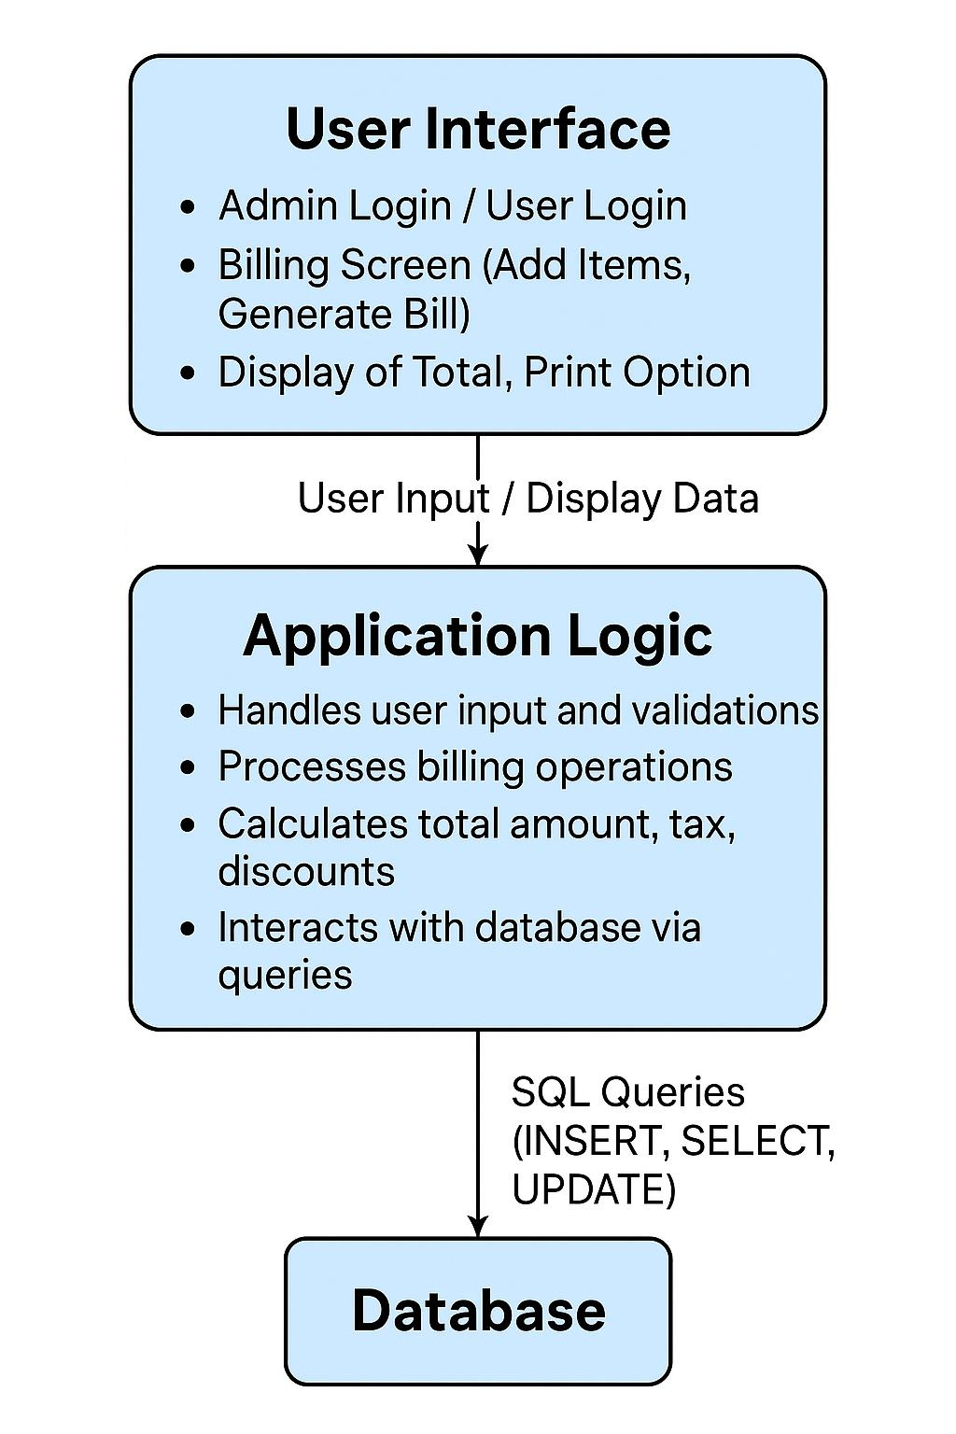
(Insert diagram showing interaction between UI, Application Logic, and Database)

4. System Requirements and Setup

Hardware Requirements
- Processor: Intel Core i3 or higher
- RAM: Minimum 4 GB
- Storage: 500 MB free space
- Display: 1366×768 or higher

Software Requirements
- Programming Language: Java (JDK 17 or above)
- Framework: Java Swing
- Database: MySQL
- Connectivity: JDBC (MySQL Connector/J)
- IDE: Visual Studio Code
- Version Control: Git and GitHub

Setup Instructions
- Install JDK and configure environment variables.
- Install MySQL and create a database named grocery_billing_db.
- Import the .sql script with tables product and sales.
- Add mysql-connector-java.jar to your project.
- Run the Java main file BillingSystem.java.

5. Procedure
- Database Design:
  - Tables:
    - product — stores product details (id, name, price, stock).
    - sales — stores transaction details (bill_no, total, date).
- Backend Logic:
  - Connect to MySQL via JDBC.
  - Fetch product price dynamically.
  - Calculate subtotal, tax, and total bill.
- User Interface (Swing):
  - Add product by code or name.
  - Display added items in a table.
  - Show total amount with tax and discount.
  - Generate bill.
- Testing:
  - Test with multiple products and ensure correct calculations.

Module 1: 1️⃣ Item.java
📁 Location: src/model/Item.java
package model;

public class Item {
private String id;
private String name;
private double price;
private int stock;

public Item(String id, String name, double price, int stock) {
this.id = id;
this.name = name;
this.price = price;
this.stock = stock;
}

// Getter methods
public String getId() { return id; }
public String getName() { return name; }
public double getPrice() { return price; }
public int getStock() { return stock; }

// Setter method
public void setStock(int stock) { this.stock = stock; }

@Override
public String toString() {
return id + "," + name + "," + price + "," + stock;
}
}

🧠 Explanation:
This class defines the blueprint for an item (like Apple, Banana, etc.).
Part | Description
private variables | store item data (encapsulation)
constructor | initializes item values
getters/setters | access and update data safely
to String() | helps save the item in CSV format

Output:
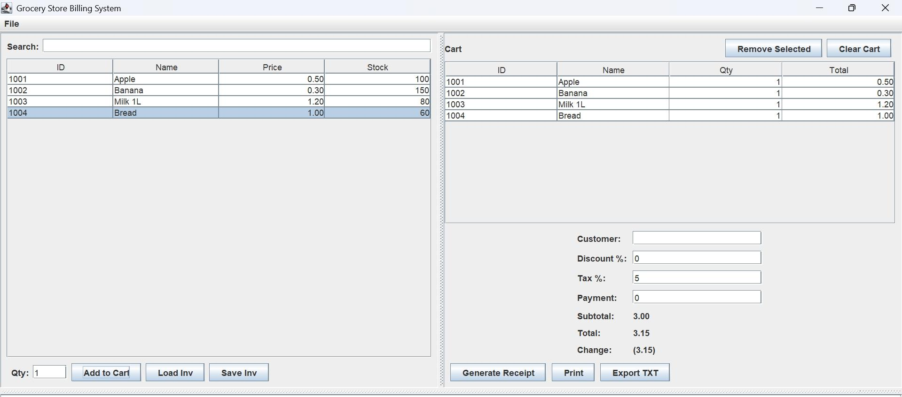

🧩 2️⃣ Inventory.java
📁 Location: src/store/Inventory.java
package store;

import model.Item;
import java.io.*;
import java.util.*;

public class Inventory {
private List<Item> items = new ArrayList<>();
private final String filePath = "data/inventory.csv";

public Inventory() {
loadInventory();
}

public List<Item> getItems() { return items; }

// Load items from CSV file
public void loadInventory() {
items.clear();
try (BufferedReader br = new BufferedReader(new FileReader(filePath))) {
String line;
while((line = br.readLine()) != null) {
String[] parts = line.split(",");
if(parts.length == 4) {
items.add(new Item(parts[0], parts[1],
Double.parseDouble(parts[2]), Integer.parseInt(parts[3])));
}
}
} catch (Exception e) {
System.out.println("Error loading inventory: " + e.getMessage());
}
}

// Save updated inventory back to CSV
public void saveInventory() {
try (PrintWriter pw = new PrintWriter(new FileWriter(filePath))) {
for (Item item : items) {
pw.println(item.toString());
}
} catch (IOException e) {
System.out.println("Error saving inventory: " + e.getMessage());
}
}

public Item findById(String id) {
for (Item i : items) {
if (i.getId().equals(id)) return i;
}
return null;
}
}

🧠 Explanation:
This class manages the inventory (stock) system.
Method | Description
loadInventory() | Reads inventory.csv and loads items into memory
saveInventory() | Writes updated items back to the file
findById() | Searches for an item by ID
items list | Stores all available products

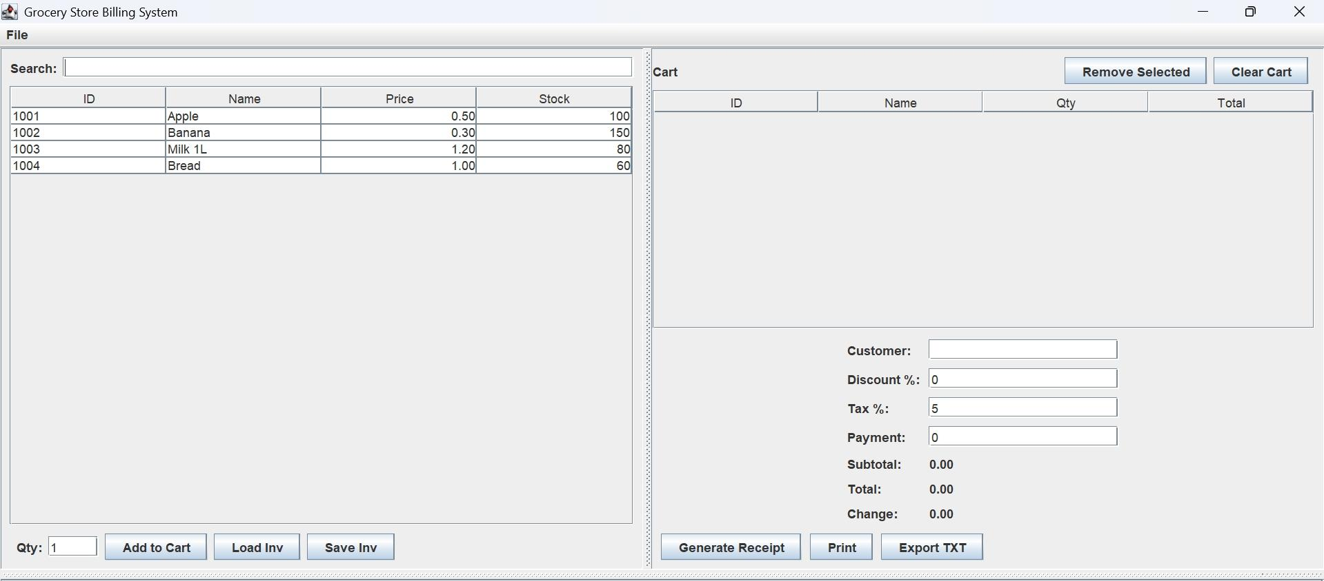
output:

🧩 3️⃣ BillingApp.java
📁 Location: src/ui/BillingApp.java
This is the main Swing GUI for billing.
package ui;

import model.Item;
import store.Inventory;
import javax.swing.*;
import javax.swing.table.DefaultTableModel;
import java.awt.*;
import java.io.*;
import java.text.SimpleDateFormat;
import java.util.*;

public class BillingApp extends JFrame {
private Inventory inventory;
private JTable tableItems, tableCart;
private JTextField txtQty, txtCustomer, txtDiscount, txtTax, txtPayment;
private JLabel lblSubtotal, lblTotal, lblChange;
private DefaultTableModel modelItems, modelCart;
private double subtotal = 0;

public BillingApp() {
super("Grocery Store Billing System");
inventory = new Inventory();
setSize(900, 500);
setDefaultCloseOperation(EXIT_ON_CLOSE);
setLayout(new GridLayout(1, 2));

// === LEFT PANEL ===
JPanel leftPanel = new JPanel(new BorderLayout());
modelItems = new DefaultTableModel(new String[]{"ID", "Name", "Price", "Stock"}, 0);
tableItems = new JTable(modelItems);
refreshItemTable();

JPanel bottomPanel = new JPanel();
txtQty = new JTextField("1", 5);
JButton btnAdd = new JButton("Add to Cart");
JButton btnLoad = new JButton("Load Inv");
JButton btnSave = new JButton("Save Inv");

bottomPanel.add(new JLabel("Qty:"));
bottomPanel.add(txtQty);
bottomPanel.add(btnAdd);
bottomPanel.add(btnLoad);
bottomPanel.add(btnSave);

leftPanel.add(new JScrollPane(tableItems), BorderLayout.CENTER);
leftPanel.add(bottomPanel, BorderLayout.SOUTH);

// === RIGHT PANEL ===
JPanel rightPanel = new JPanel(new BorderLayout());
modelCart = new DefaultTableModel(new String[]{"ID", "Name", "Qty", "Total"}, 0);
tableCart = new JTable(modelCart);
rightPanel.add(new JScrollPane(tableCart), BorderLayout.CENTER);

JPanel btnPanel = new JPanel();
JButton btnRemove = new JButton("Remove Selected");
JButton btnClear = new JButton("Clear Cart");
btnPanel.add(btnRemove);
btnPanel.add(btnClear);
rightPanel.add(btnPanel, BorderLayout.NORTH);

// Billing form
JPanel billPanel = new JPanel(new GridLayout(9, 2));
txtCustomer = new JTextField();
txtDiscount = new JTextField("0");
txtTax = new JTextField("5");
txtPayment = new JTextField("0");
lblSubtotal = new JLabel("0.00");
lblTotal = new JLabel("0.00");
lblChange = new JLabel("0.00");

billPanel.add(new JLabel("Customer:")); billPanel.add(txtCustomer);
billPanel.add(new JLabel("Discount %:")); billPanel.add(txtDiscount);
billPanel.add(new JLabel("Tax %:")); billPanel.add(txtTax);
billPanel.add(new JLabel("Payment:")); billPanel.add(txtPayment);
billPanel.add(new JLabel("Subtotal:")); billPanel.add(lblSubtotal);
billPanel.add(new JLabel("Total:")); billPanel.add(lblTotal);
billPanel.add(new JLabel("Change:")); billPanel.add(lblChange);

JButton btnReceipt = new JButton("Generate Receipt");
JButton btnPrint = new JButton("Print");
JButton btnExport = new JButton("Export TXT");

billPanel.add(btnReceipt);
billPanel.add(btnPrint);
billPanel.add(btnExport);

rightPanel.add(billPanel, BorderLayout.SOUTH);

add(leftPanel);
add(rightPanel);

// === BUTTON ACTIONS ===
btnAdd.addActionListener(e -> addToCart());
btnRemove.addActionListener(e -> removeSelected());
btnClear.addActionListener(e -> clearCart());
btnLoad.addActionListener(e -> refreshItemTable());
btnSave.addActionListener(e -> inventory.saveInventory());
btnReceipt.addActionListener(e -> generateReceipt());
}

private void refreshItemTable() {
modelItems.setRowCount(0);
for (Item i : inventory.getItems()) {
modelItems.addRow(new Object[]{i.getId(), i.getName(), i.getPrice(), i.getStock()});
}
}

private void addToCart() {
int row = tableItems.getSelectedRow();
if (row < 0) return;
String id = modelItems.getValueAt(row, 0).toString();
String name = modelItems.getValueAt(row, 1).toString();
double price = Double.parseDouble(modelItems.getValueAt(row, 2).toString());
int qty = Integer.parseInt(txtQty.getText());
double total = price * qty;
modelCart.addRow(new Object[]{id, name, qty, total});
subtotal += total;
lblSubtotal.setText(String.format("%.2f", subtotal));
calculateTotal();
}

private void removeSelected() {
int row = tableCart.getSelectedRow();
if (row >= 0) {
double amt = Double.parseDouble(modelCart.getValueAt(row, 3).toString());
subtotal -= amt;
modelCart.removeRow(row);
lblSubtotal.setText(String.format("%.2f", subtotal));
calculateTotal();
}
}

private void clearCart() {
modelCart.setRowCount(0);
subtotal = 0;
lblSubtotal.setText("0.00");
calculateTotal();
}

private void calculateTotal() {
double discount = Double.parseDouble(txtDiscount.getText());
double tax = Double.parseDouble(txtTax.getText());
double total = subtotal - (subtotal * discount / 100) + (subtotal * tax / 100);
lblTotal.setText(String.format("%.2f", total));

double payment = Double.parseDouble(txtPayment.getText());
double change = payment - total;
lblChange.setText(String.format("%.2f", change));
}

private void generateReceipt() {
String customer = txtCustomer.getText().isEmpty() ? "Unknown" : txtCustomer.getText();
String fileName = "receipts/receipt_" + new SimpleDateFormat("yyyyMMddHHmmss").format(new Date())
+ "-" + UUID.randomUUID().toString().substring(0, 8) + ".txt";

try (PrintWriter pw = new PrintWriter(new FileWriter(fileName))) {
pw.println("========= GROCERY STORE =========");
pw.println("Invoice: " + UUID.randomUUID().toString().substring(0, 12));
pw.println("Date: " + new SimpleDateFormat("yyyy-MM-dd HH:mm:ss").format(new Date()));
pw.println("Customer: " + customer);
pw.println("----------------------------------");
pw.printf("%-6s %-10s %-4s %-5s%n", "ID", "Name", "Qty", "Total");
for (int i = 0; i < modelCart.getRowCount(); i++) {
pw.printf("%-6s %-10s %-4s %-5s%n",
modelCart.getValueAt(i, 0),
modelCart.getValueAt(i, 1),
modelCart.getValueAt(i, 2),
modelCart.getValueAt(i, 3));
}
pw.println("----------------------------------");
pw.println("Subtotal: " + lblSubtotal.getText());
pw.println("Discount (" + txtDiscount.getText() + "%): " + (subtotal * Double.parseDouble(txtDiscount.getText()) / 100));
pw.println("Tax (" + txtTax.getText() + "%): " + (subtotal * Double.parseDouble(txtTax.getText()) / 100));
pw.println("Total: " + lblTotal.getText());
pw.println("Payment: " + txtPayment.getText());
pw.println("Change: " + lblChange.getText());
pw.println("========= THANK YOU =========");
} catch (IOException e) {
JOptionPane.showMessageDialog(this, "Error writing receipt!");
}

JOptionPane.showMessageDialog(this, "Receipt saved!");
}
}

🧠 Explanation:
Section | Description
GUI Setup | Builds the left panel (inventory) and right panel (cart + billing)
Add to Cart | Adds selected item with quantity
Remove/Clear | Deletes items from cart
Calculate Total | Computes subtotal, tax, discount, total, change
Generate Receipt | Creates .txt file under receipts/ folder

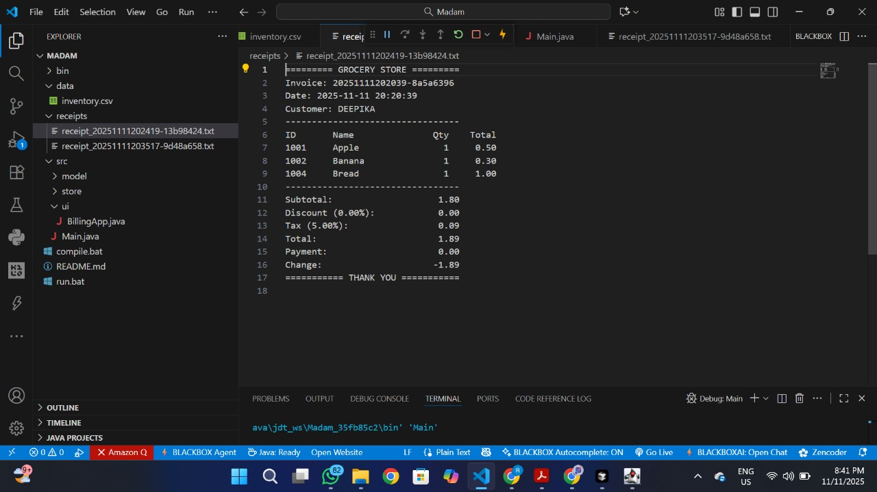
Output:

9. PO–PSO Mapping:
PO/PSO | Description | Relevance (1–3)
PO1 | Apply Java programming and database concepts for real-world billing | 3
PO2 | Design efficient billing algorithms with accuracy and speed | 3
PO3 | Develop a GUI-based Java application for store billing | 3
PO4 | Use tools like VS Code, MySQL, and JDBC effectively | 3
PO5 | Maintain secure and error-free billing records | 3
PO6 | Collaborate in team development and documentation | 2
PO7 | Promote digital automation in small retail businesses | 2
PO8 | Ensure ethical data handling and security | 3
PSO1 | Implement intelligent billing and predictive restock algorithms | 3
PSO2 | Analyze sales data for performance improvement | 2
PSO3 | Prepare for research in smart retail automation | 2

8. Conclusion & Future Work
The Billing System for Grocery Store efficiently automates product billing and reduces manual work.
It ensures accuracy, maintains transaction records, and simplifies the overall billing process.
The integration of Java Swing for the user interface and MySQL for the database provides a scalable and secure architecture.

Future Enhancements
- Integration with barcode scanners for automatic product entry.
- Automatic stock updates after billing.
- Generating PDF bills for customers.
- Multi-user login system for cashiers and managers.
- Data analytics dashboard for daily and monthly sales tracking.

10. References
- Herbert Schildt, Java: The Complete Reference, 11th Edition, McGraw-Hill Education, 2019.
- Kathy Sierra & Bert Bates, Head First Java, 2nd Edition, O'Reilly Media, 2005.
- Oracle Java Documentation — https://docs.oracle.com/javase/
- MySQL Official Documentation — https://dev.mysql.com/doc/
- GeeksforGeeks — Java Swing and JDBC Tutorials — https://www.geeksforgeeks.org/java/
- GitHub — Sample Grocery Billing System Repository — https://github.com/yourusername/GroceryBillingSystem

